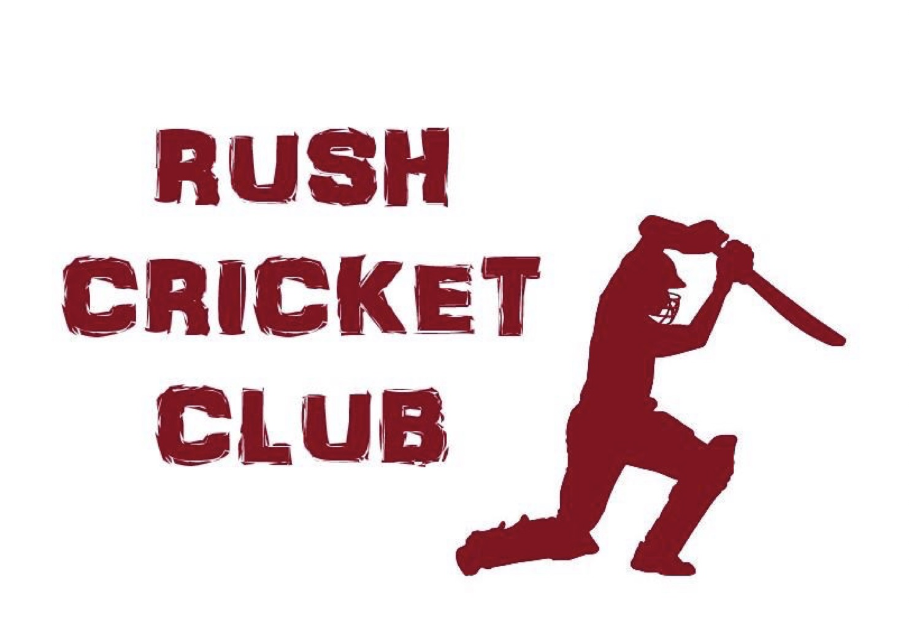

CHILDREN’S CODE OF CONDUCT

It is the aim of this club that children’s sport will be conducted in a safe, positive and encouraging environment, guided by what is best for the child. Below are the guidelines for young people and their parents/guardians in our club.

Young players should always:

Treat sport leaders (coaches, umpires etc) with respect.
Play fairly at all times.
Respect team members, give them full support when they do well and when things go wrong.
Respect opponents, be modest in victory and gracious in defeat.
Abide by the rules set down by Leaders when travelling to away games
Talk to the Children’s Officer if they have any problems.

Young players should never:

Cheat
Shout at or argue with umpires, team mates or opponents.
Use bullying tactics to isolate a player.
Use violence or physical contact to intimidate another player.
Take banned substances.
Tell lies or spread rumours about another child.

Parents Remember that children learn by example.

Show respect for Leaders (coaches, assistants, umpires etc.)
Show respect for your child’s team mates and the opposing team.
Encourage children to play by the rules.
Behave responsibly on the sideline, in particular never show dissent with an umpiring decision as this will be observed by nearby children.
Focus on effort, fun and participation rather than results.
Never use foul language.

